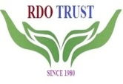
RURAL DEVELOPMENT ORGANISATION TRUST

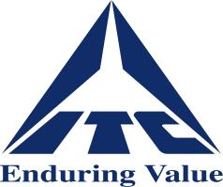
ITC MISSION SUNEHRA KAL

Comprehensive Community Development Programme (CCDP)

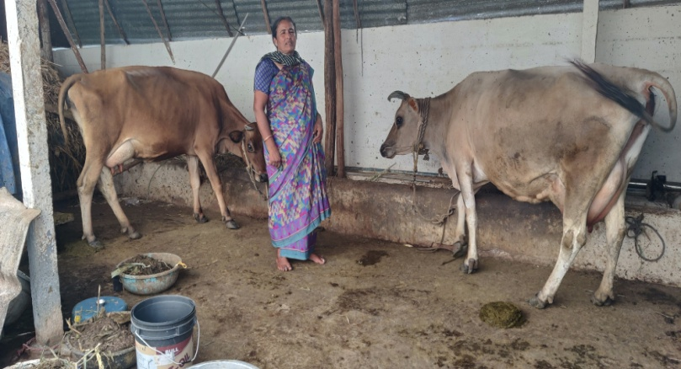
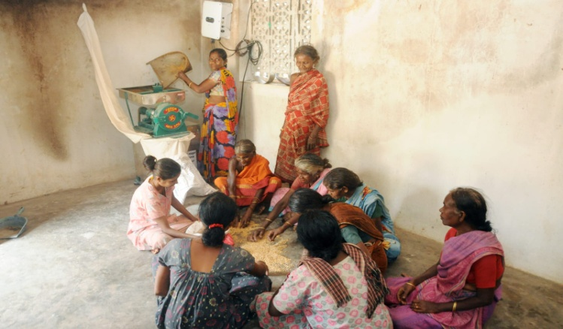
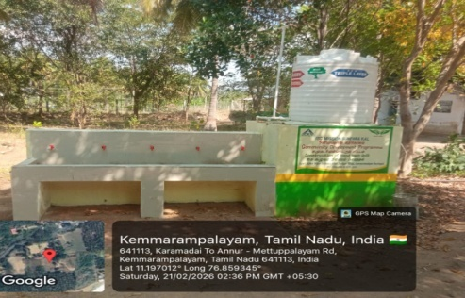
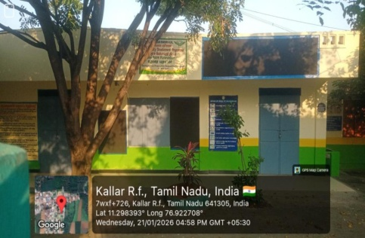
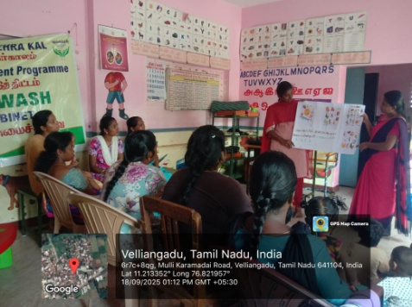
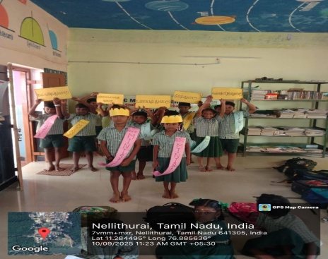
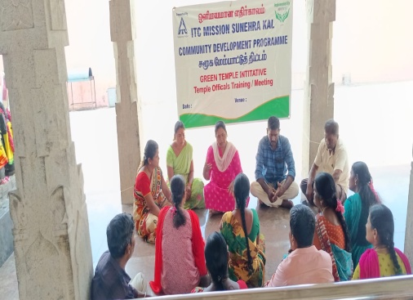
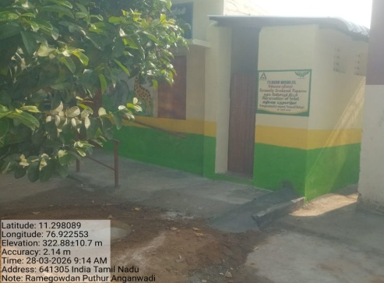
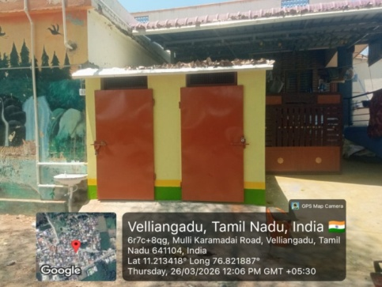
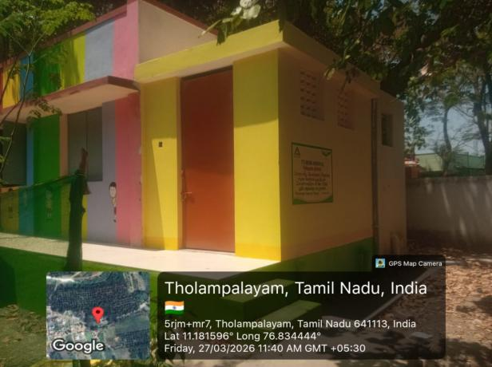
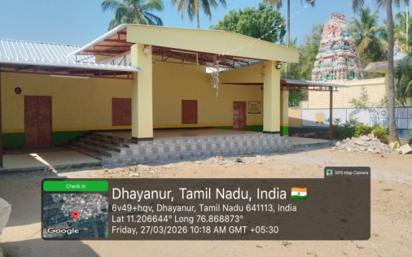
Annual Report – 2025-2026

Annual Report – 2025-2026
The Rural Development Organisation (RDO Trust) was established in 1980 by social activist N. K. Perumal with a strong commitment to serving rural communities through innovative and impactful development initiatives. RDO Trust designs and implements sustainable solutions by fostering strong collaborations among stakeholders, building local capacities, promoting livelihood diversification to address climate change, and influencing policy at the district, state, and national levels through evidence-based insights and strategic networking.
Over the decades, RDO Trust has successfully replicated its pioneering interventions across India, reaching remote villages and supporting communities living in extreme poverty. The organisation’s dedicated team of professionals and volunteers has demonstrated excellence in Education, Women’s Empowerment, Water and Sanitation, Solid Waste and Faecal Sludge Management, and the promotion of circular economy principles linking sanitation and agriculture.
In 2019, RDO Trust entered into a transformative partnership with ITC Limited under Mission Sunehra Kal, launching comprehensive community development programmes across 17 Panchayats in the Karamadai Block of Coimbatore District, Tamil Nadu. This collaboration has significantly enhanced the scale and impact of RDO Trust’s work.

Vision: To build partnerships with vulnerable rural poor comprising of mainly the disadvantaged women and children for positive social change through education, economic and social empowerment that focuses more on a synergy with the environment.

Mission: The RDO mission is to promote the well-being of rural people, innovation to solve challenges related to environment, climate change, water and sanitation, food security, reduce inequality, and zero hunger and quality education. Website: www.rdotrust.org

Solid Waste Management Initiatives:
RDO Trust implemented Solid Waste Management (SWM) programmes across seventeen Panchayats, focusing on source segregation, home composting, and cluster composting to promote sustainable waste practices.

Key Interventions:
- Capacity-building and awareness sessions for Panchayat Green Workers, Panchayat officials, and village residents
- Household-level training on waste segregation, organic composting, and safe handling of recyclable and non-recyclable waste

Key Outcomes:
- 27,398 households reached through community engagement
- 12,810 households adopted home composting
- 24,115 households practising source-level segregation
- Cluster composting centres established and strengthened
These interventions reduced landfill dependence and contributed to cleaner, healthier, and environmentally responsible communities.

SDG Alignment
- SDG 11: Sustainable Cities & Communities
- SDG 12: Responsible Consumption & Production
- SDG 13: Climate Action

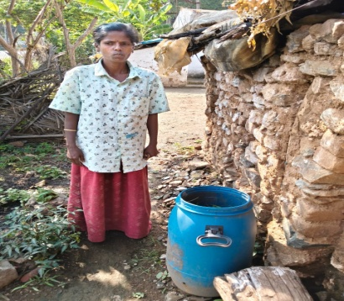
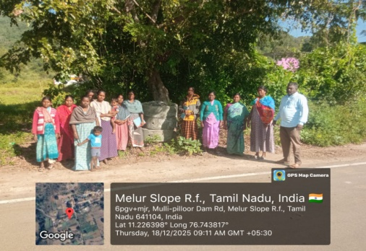
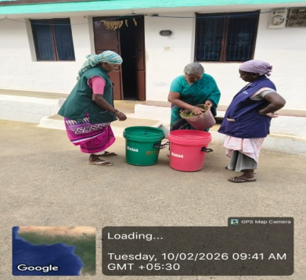

School Infrastructure Development & Soft Components:
RDO Trust implemented school infrastructure and soft component interventions in 11 government schools across seven Panchayats, benefiting 1,019 students, with a special focus on education.

Key Interventions & Outcomes
- Governance & Student Leadership: Conducted 49 SMC meetings and 49 Child Cabinet meetings, strengthening school governance and student participation.
- WASH & Hygiene Promotion: Implemented WASH Kiosks in four schools (290 students) and conducted personal hygiene training in 49 schools, reaching 3,552 students.
- Infrastructure Upgradation: Improved toilets, classrooms, dining halls, and installed handwashing units to enhance hygiene and learning environments.
These efforts improved school facilities, hygiene practices, and student engagement.

Model School Development:
Out of eight selected schools, four were developed as model schools and four are progressing as emerging schools.

Focus Areas:
- Nutrition gardens to support mid-day meals
- Solid and liquid waste management systems
- Improved water, sanitation, classrooms, and play areas
- Strengthened Child Cabinets and SMCs for inclusive governance
These interventions promote child-friendly, inclusive, and sustainable learning environments.

Special Events:
Schools celebrated key days including World Hand Wash Day, National Education Day, Children’s Day, Constitution Day, Republic Day, National Girl Child Day, World Pulses Day, and World Water Day to promote awareness and civic values.
Awareness sessions, discussions, and student-led activities were conducted, with 589 students participating enthusiastically. These events strengthened students’ understanding of hygiene, education, constitutional values, nutrition, gender equality, and water conservation, contributing to holistic learning and social awareness.

SDG Alignment:
- SDG 4: Quality Education
- SDG 3: Good Health & Well-being
- SDG 5: Gender Equality
- SDG 6: Clean Water & Sanitation

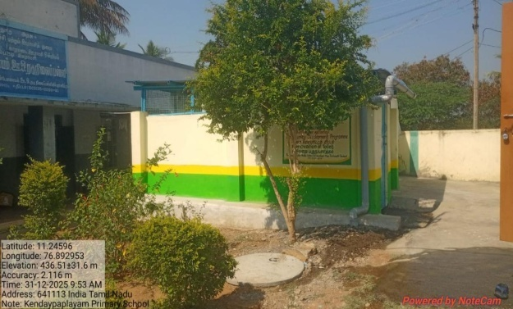
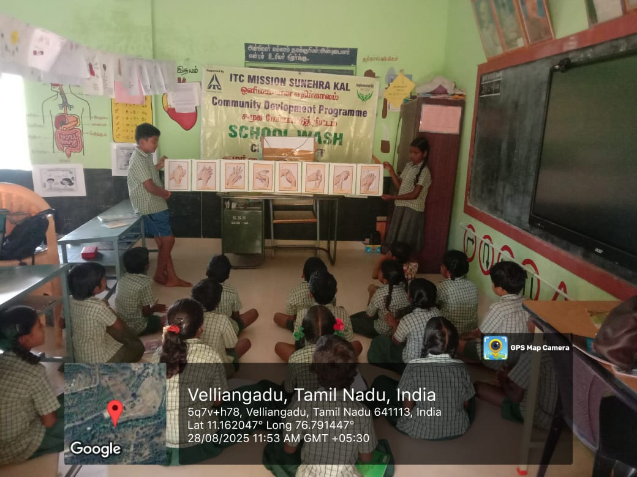
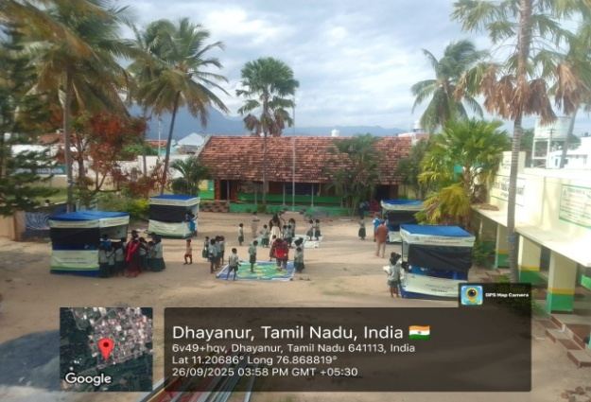
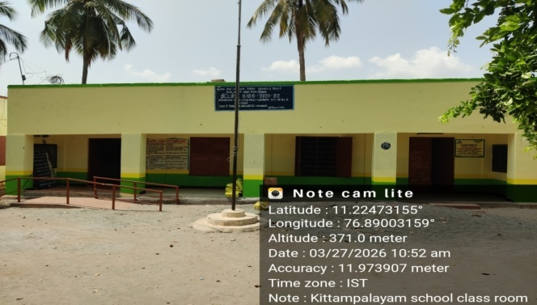

Anganwadi Infrastructure Development & Soft Components:
To strengthen early childhood care and education, RDO Trust implemented infrastructure and soft component interventions in five Anganwadi centres across five Panchayats, benefiting 95 children.

Key Interventions:
- Infrastructure Upgradation: Improved physical facilities to create safe, child-friendly, and hygienic environments.
- Community Engagement: Strengthened 44 Mothers’ Committees to support service monitoring, child nutrition, hygiene practices, and parent–worker coordination.
These efforts enhanced service quality and increased community ownership of Anganwadi services.

Mother and Child Health (MCH):
Health and nutrition training was conducted for 423 mothers across 44 Anganwadi centres to prevent malnutrition and anaemia among mothers and children.

Focus Areas:
- Balanced diet and age-appropriate nutrition
- Early identification and management of anaemia and growth delays
- Exclusive breastfeeding and complementary feeding practices
- Awareness on iron–folic acid supplementation, health check-ups, and government schemes
The programme empowered mothers to make informed health and nutrition decisions, contributing to healthier families.

Poshan Maah Celebration:
Poshan Maah was celebrated at Anganwadi centres under POSHAN Abhiyaan to promote nutrition among children, pregnant women, and lactating mothers.
Activities included nutrition awareness sessions, child growth monitoring, promotion of locally available nutritious foods, and hygiene education. The celebration strengthened community participation, encouraged positive behaviour change, and supported the goal of building a healthy and well-nourished community.

SDG Alignment:
- SDG 2: Zero Hunger
- SDG 3: Good Health & Well-being
- SDG 4: Quality Education
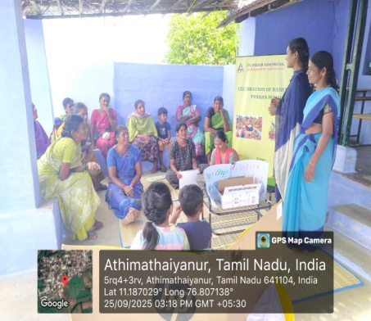
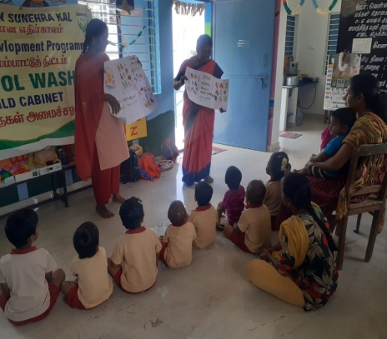
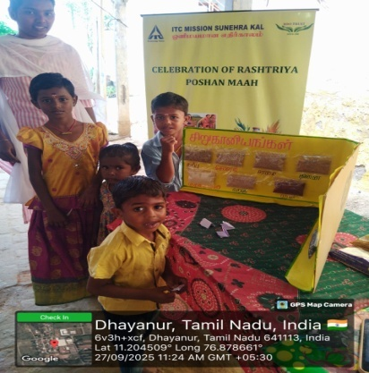
- SDG 5: Gender Equality

SHG Formation & Women’s Economic Empowerment:
As part of RDO Trust’s commitment to women’s economic empowerment, Self-Help Groups (SHGs) were formed and strengthened to improve access to finance and livelihood opportunities.

Key Achievements
- ₹53 lakhs mobilised from ICICI Bank, benefiting 123 SHG members for income-generating activities.
- Women utilised the support to start or expand small enterprises, leading to improved household income and financial independence.

Financial Literacy & Scheme Linkage Training:
To enhance SHG capacity and promote responsible financial practices, a Financial Literacy and Scheme Linkage Training programme was conducted in collaboration with ITC.

Highlights:
- 10,073 women from 994 SHGs participated in the training.
- Sessions were facilitated by RDO and ITC, with support from TNSRLM staff and PLF Cluster Coordinators.
- Participants received a Financial Literacy Handbook for continued reference.

Key Topics Covered
- Budgeting and savings
- Responsible borrowing and debt management
- Access to credit, insurance, pensions, and government schemes
The programme strengthened women’s financial decision-making skills, contributing to economic resilience, self-reliance, and sustainable livelihoods.

SDG Alignment:
- SDG 1: No Poverty
- SDG 5: Gender Equality
- SDG 8: Decent Work & Economic Growth

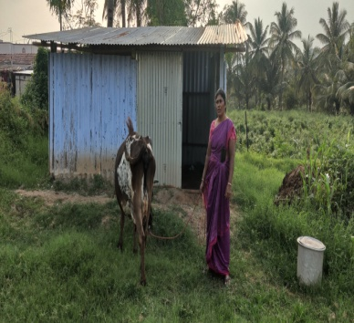
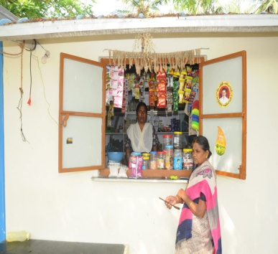
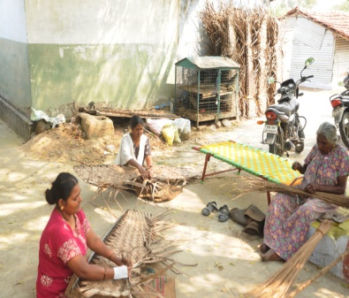
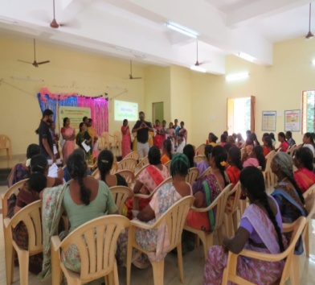

Green Temple Initiative:
The Green Temple Initiative was launched to promote environmental sustainability and effective waste management within temple premises and among devotees. The programme aimed to transform temples into models of ecological responsibility by integrating eco-friendly practices into daily operations and religious activities.
Key Achievements
- Baseline Assessment: Conducted assessments in 493 temples to understand existing practices, infrastructure, and opportunities for green interventions.
- Devotee Engagement: Oriented 3,641 devotees on environmental stewardship and responsible practices in religious spaces.
- Capacity Building: Trained 493 temple officials and 321 community volunteers on waste management, water conservation, plastic reduction, and energy efficiency.
- Leadership Development: Developed 93 Master Trainers to support local implementation and engaged 123 donors through financial and in-kind contributions.
- Reward & Recognition: Organised recognition programmes across three districts to appreciate the contributions of donors, temple officials, trainers, and volunteers, encouraging sustained community participation.
- Programme Rollout: Successfully implemented the Green Temple model in 493 temples, embedding environmentally responsible practices into routine temple activities and festivals.
The initiative strengthened community participation, reduced environmental impact in religious spaces, and positioned temples as powerful agents of environmental awareness and behavioural change.

SDG Alignment:
- SDG 11: Sustainable Cities & Communities
- SDG 12: Responsible Consumption & Production
- SDG 13: Climate Action
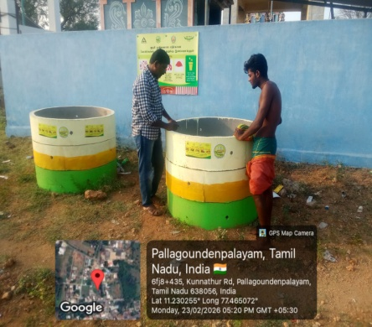
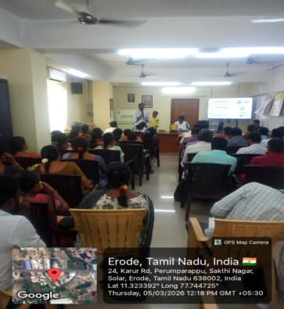
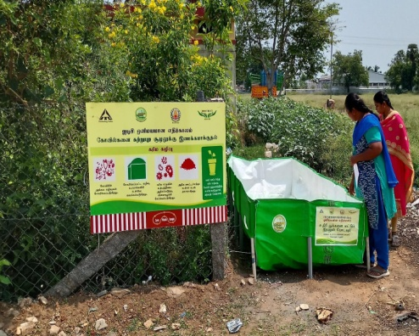

Light House Initiative:
The Light House Initiative aims to develop model Panchayats for integrated sanitation and waste management through local solutions, community participation, and capacity building.

Key Interventions:
- Dissemination of IEC materials on sanitation, SWM, LWM, and FSM
- Community education on the safe reuse of treated faecal sludge for kitchen gardens and agriculture, promoting circular sanitation

Key Outcomes:
- Awareness programmes covered 17 Panchayats in Karamadai Block, strengthening source segregation and waste management practices
- IIT Madras (IITM), Chennai, conducted technical assessments of LWM units and drainage endpoints and provided design and performance recommendations

SDG Alignment:
- SDG 6: Clean Water & Sanitation
- SDG 11: Sustainable Communities
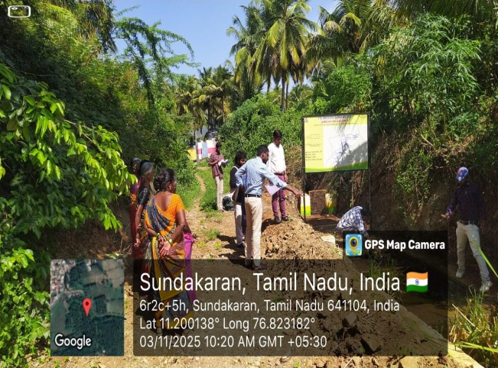
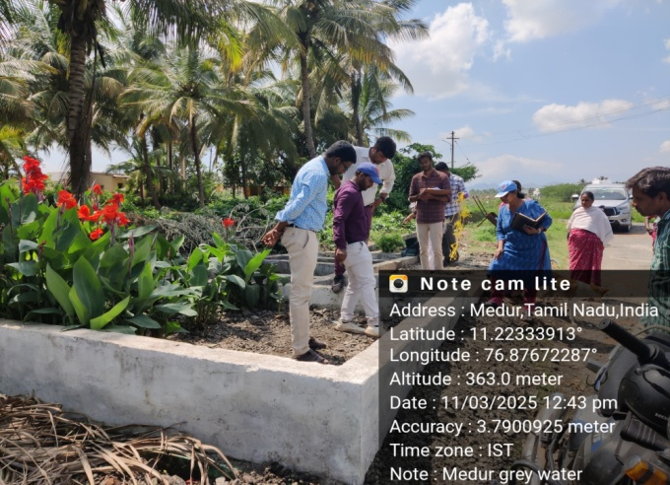
- SDG 12: Responsible Consumption

Other Activities:
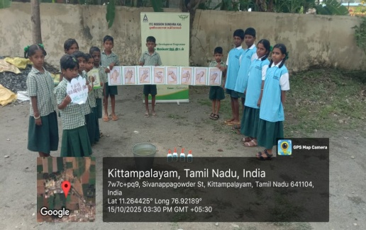
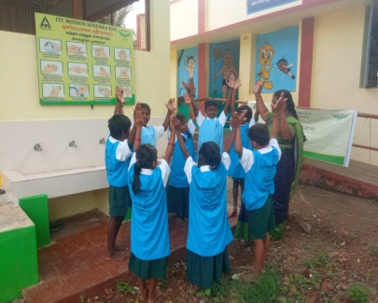
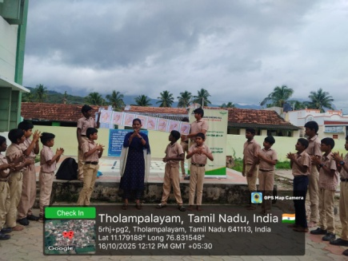
World Hand Wash Day:
Celebrated in five schools, engaging 195 students through interactive sessions and live demonstrations on proper handwashing practices, reinforcing hygiene as a key measure for disease prevention.

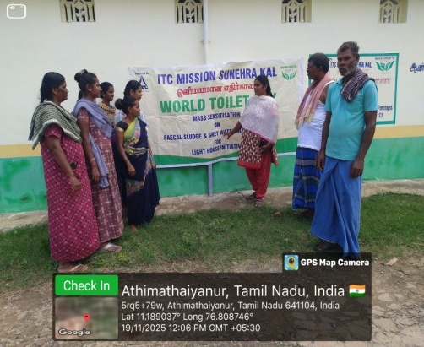
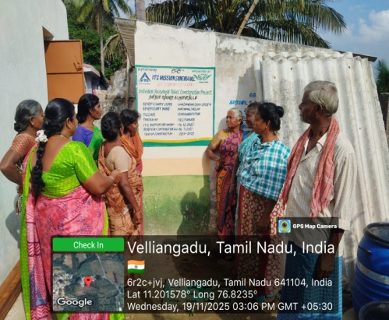
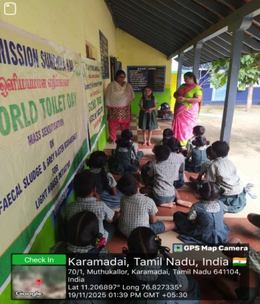
World Toilet Day:
Observed in three villages and one school, reaching 22 students and 35 beneficiaries, to promote awareness on sanitation, safe toilet usage, and dignity.
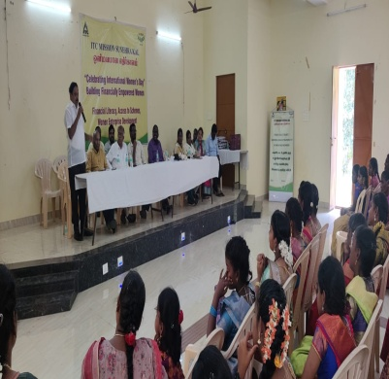
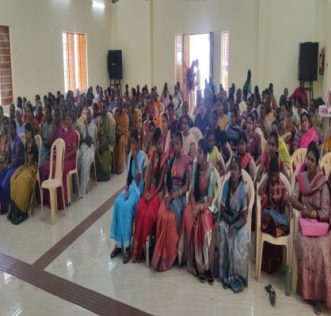
International Women’s Day:
Celebrated with 206 SHG members, focusing on financial literacy for women’s empowerment. Interactive sessions and expert discussions enhanced awareness on savings, credit access, and government welfare schemes, encouraging economic independence.

Acknowledgements:
The Rural Development Organisation (RDO) sincerely thanks all individuals, institutions, and partners whose support made the Sanitation and Solid Waste Management Project, implemented in partnership with ITC in the Karamadai Block, a meaningful success.
We gratefully acknowledge the guidance and administrative support of district and block-level officials, including the District Administration, Education Department, ICDS, TNSRLM, Swachh Bharat Mission, and Block Development Offices.
We also extend our heartfelt appreciation to the Panchayat Presidents of Kemmarampalayam, Tholampalayam, Maruthur, Kalampalayam, Velliyankadu, Nellithurai, and Thekkampatti Panchayats for their leadership and community coordination.
Our sincere thanks to ITC for its continued partnership and commitment to community-led development. We especially acknowledge Mr. Manish Kumar, Mr. Chandrasekhar, and Mr. Dinesh Moorthy for their regular field visits, strategic guidance, and constant support.
We look forward to strengthening this collaboration and working together towards sustainable rural development and community empowerment.

Case Study 1: Kohila – Tailoring Enterprise Growth through SHG Credit:
Location | Aathimathaiyanur Village, Karamadai Block
Beneficiary | Ms. Kohila
Programme | ITC Mission Sunehra Kal – Financial Literacy
Implementing Partner | Rural Development Organisation (RDO Trust)
Financial Institution | Indian Overseas Bank

Background: Kohila, a B.Sc. Computer Science graduate from Aathimathaiyanur village, started tailoring as a home-based livelihood. Initially she worked using a manual sewing machine purchased from personal savings. The manual machine limited her productivity and caused physical strain, restricting her income generation potential.
Intervention:Through financial literacy sessions conducted by RDO Trust under the ITC MSK programme, Kohila became a member of the Lotus Self Help Group. The SHG accessed a bank loan from Indian Overseas Bank. Kohila received ₹1,00,000 from the group loan which she invested in purchasing an electric sewing machine and expanding her tailoring work.
Indicator | Before Intervention | After Intervention
Blouses stitched per day | 5 | 10
Monthly income | Rs 10,000 | Rs 20,000

Impact Highlights
• Productivity doubled after upgrading to an electric sewing machine
• Monthly income increased significantly
• Improved financial independence and confidence
• Demonstrates how access to credit can support women entrepreneurship

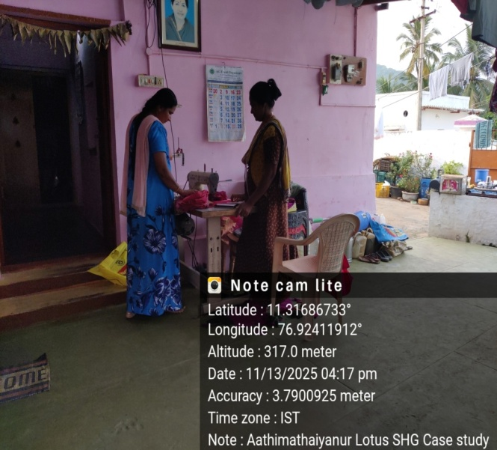
"Today I feel confident running my own tailoring enterprise and contributing to my family income."
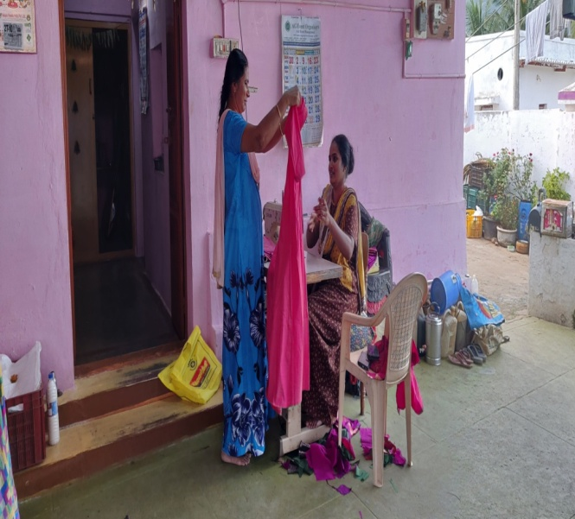

Case Study 2: Rani – Dairy Livelihood Expansion
Location | Aathimathaiyanur Village, Karamadai Block
Beneficiary | Ms. Rani
Programme | ITC Mission Sunehra Kal – Financial Literacy
Implementing Partner | Rural Development Organisation (RDO Trust)
Financial Institution | Indian Overseas Bank

Background:Rani is a small farmer managing two acres of land and one dairy cow. Due to health challenges faced by her husband, she became the primary earner in the household. While dairy farming had potential, she lacked capital to expand.
Intervention:Through the financial literacy programme facilitated by RDO Trust, Rani learned about savings, financial planning, and productive investment of loans. Through the Lotus Self Help Group she accessed a bank loan of ₹1,00,000 and used the funds to purchase an additional dairy cow.
Indicator | Before Intervention | After Intervention
Monthly household income | Rs 30,000 | Rs 49,000
Number of dairy animals | 1 | 2

Impact Highlights:

• Income diversification through dairy activity
• Increased household financial stability
• Improved ability to manage household expenses
• Enhanced resilience against agricultural risks

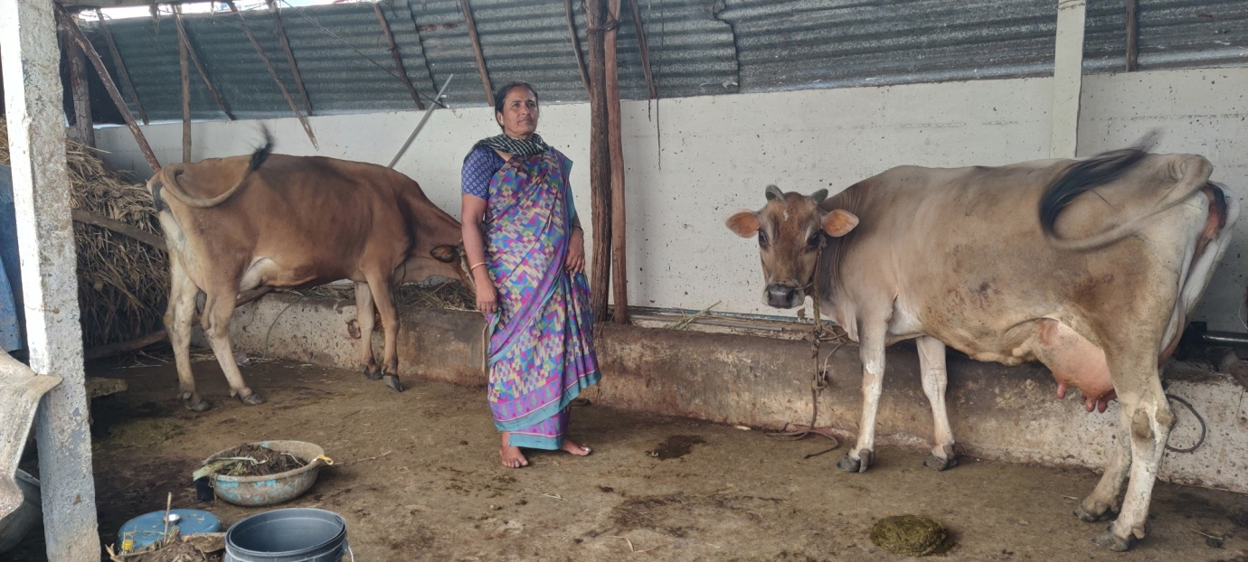
"With the support of the SHG and financial literacy training, I could expand my dairy activity and increase our family income."

Case Study 3: Murugeswari&Vaidegi – Livelihood Diversification
Location | Karamadai Region
Beneficiaries | Ms. Murugeswari and Ms. Vaidegi
Programme | ITC Mission Sunehra Kal – Financial Literacy
Implementing Partner | Rural Development Organisation (RDO Trust)

Background:
Murugeswari and Vaidegi traditionally depended on mat weaving for their livelihood. The income frommat weaving was limited and seasonal, making it difficult for the families to meet regular household expenses.

Intervention:
After participating in financial literacy training organised by RDO Trust, both sisters joined the Sri Pannari Amman Self Help Group and accessed small loans. They diversified their livelihoods while continuing mat weaving.Murugeswari started a petty shop and Vaidegi started a weekend meat shop.
Indicator | Before Intervention | After Intervention
Average monthly income | Rs 5,000 | Rs 13,000–₹17,000
Income sources | Mat weaving | Mat weaving + small enterprises

Impact Highlights:
• Increased and diversified income streams
• Reduced livelihood vulnerability
• Improved financial planning and business management
• Strengthened women-led micro enterprises
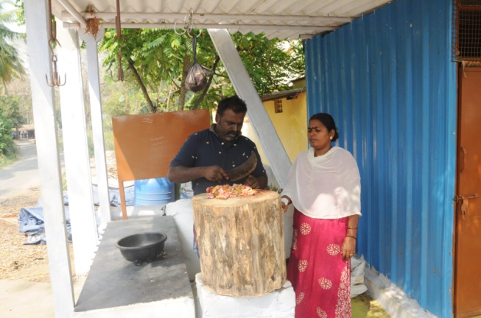
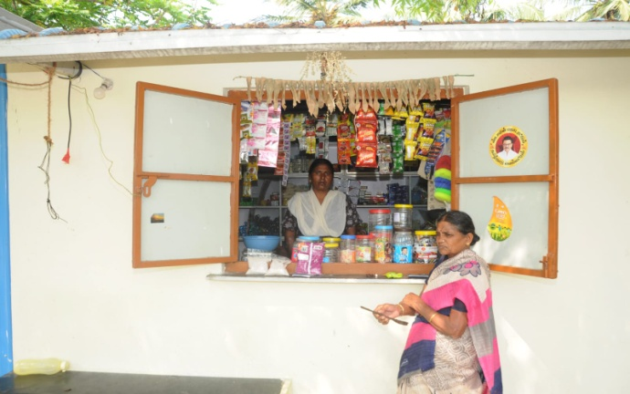
"The SHG and financial literacy training helped us start new businesses and improve our family income."
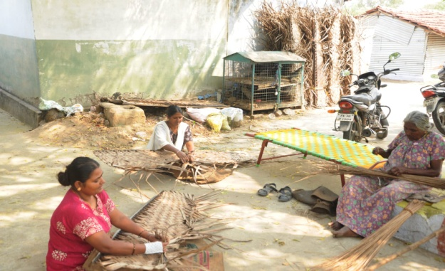

Case Study 4 - Financial Literacy Training for Tribal Self-Help Groups

Particulars | Details
Villages | Pillurdam&Athikadavu
Training Dates | 08.02.2025 & 22.02.2025
Target Group | Tribal Women Self Help Groups (SHGs)
Organized By | ITC-MSK in partnership with RDO Trust
Focus Area | Financial Literacy & SHG Strengthening

Background: In the tribal villages of Pillurdam and Athikadavu, several Self-Help Groups had become inactive due to irregular meetings and limited financial awareness. To strengthen these community institutions, ITC-MSK, with the support of Rural Development Organisation (RDO Trust), organized Financial Literacy Training sessions for tribal SHG members.

The initiative aimed to build financial knowledge, encourage savings habits, and improve access to banks and government welfare schemes. This effort is aligned with ITC’s sustainability approach of promoting financial inclusion and strengthening community institutions for sustainable livelihoods.

Training Components | Learning Outcomes
Importance of SHG meetings | Strengthened group participation and decision making
Savings & money management | Improved household financial planning
Record keeping | Proper maintenance of SHG registers
Access to bank credit | Awareness on responsible loan utilisation
Government schemes | Knowledge on welfare schemes for tribal communities

Impact and Outcomes: After the training, SHG members became more confident in accessing government support programmes. With guidance from the programme team, several SHGs applied for livelihood support schemes.In October 2025, many SHGs successfully received Solar Small Grain Processing Machines from the District Adi Dravidar and Tribal Welfare Department under the TholkudiThittam Scheme (2024-2025).This support enabled SHG members to start small-scale grain processing activities, generating additional income and strengthening their livelihoods.
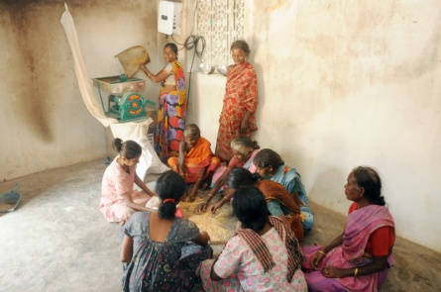
Impact Highlights:
- Revival of inactive tribal Self Help Groups
- Improved financial awareness and savings behavior
- Access to government livelihood schemes
- Additional income generation for tribal households

“Financial literacy has helped our Self-Help Group restart regular meetings and access government support. With the grain processing machine, we are now able to earn additional income and support our families.” SHG Member, Athikadavu Village

Case Study: 5 - Dhasampalayam Middle School – Sanitation & Hygiene Improvement
Parameter | Details
Location | Dhasampalayam Village
Institution | Dhasampalayam Middle School
Programme | ITC – Mission Sunehra Kal - School Sanitation & Hygiene Improvement
Implementing Partner | Rural Development Organisation (RDO Trust)
Support Type | Infrastructure Development

Background:
Dhasampalayam Middle School lacked adequate sanitation and hygiene infrastructure. There was no proper water connection, students had to carry water to use toilets, and the absence of a dining hall forced children to eat in open areas. Girls also lacked safe menstrual hygiene facilities, affecting comfort, dignity, and hygiene practices.

Intervention:
RDO Trust supported the construction of a dining hall, girls’ toilet with incinerator, and handwash units with water supply. Hygiene awareness was strengthened, and the Child Cabinet was actively engaged to promote cleanliness, handwashing, and waste management within the school.

Indicators:
Indicator | Before Intervention | After Intervention
Water availability in toilets | No water connection | Continuous water supply
Dining facility | Open space | Covered dining hall
Handwashing practice | Irregular | Regular among students
Menstrual hygiene facility | Not available | Safe toilets with incinerator

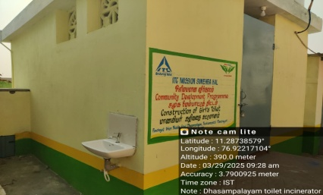
Impact Highlights:
- Improved hygiene behaviour and regular handwashing
- Safe and dignified menstrual hygiene for girl students
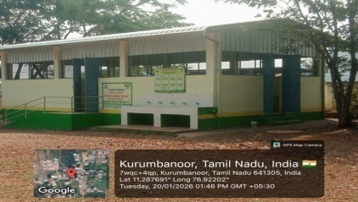
- Comfortable dining space in all weather conditions
- Cleaner, healthier school environment
- Active student leadership through the Child Cabinet

Stakeholder Feedback:
"Earlier students had to carry water for toilet use. Now, with proper water supply and sanitation facilities, toilet usage is easy, hygienic, and safe for all students." – Headmaster

Case Study: 6 - Waste Management at Sasolieswarar Temple
Parameter | Details
Location | Perundurai, Erode District
Institution | Sasolieswarar Temple
Programme | ITC Mission Sunehra Kal - Temple Waste Management
Implementing Partner | Rural Development Organisation (RDO Trust)
Technology Used | Compost Bag System

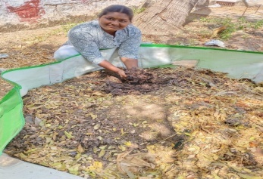
Background:
Sasolieswarar Temple receives a large number of devotees daily, generating substantial floral and organic waste from rituals and offerings. Earlier, this waste was dumped openly near the temple premises, causing foul odor, environmental pollution, and inconvenience to devotees.

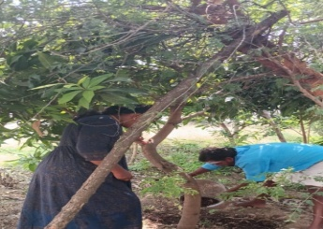
Intervention:
To address this issue, a compost bag system was introduced. Compost bags costing ₹2,500 each, with a capacity of 100–150 kg, were installed. Dedicated baskets were placed for floral waste collection, followed by segregation. The organic waste is treated with microbial culture and converted into compost within 45–60 days.

Indicators:
Indicator | Before Intervention | After Intervention
Waste disposal method | Open dumping | Scientific composting
Floral waste management | Unsegregated | Segregated at source
Temple cleanliness | Poor | Significantly improved
Plastic contamination | High | Reduced by 50–60%

Impact Highlights:
- Complete elimination of open dumping
- Improved temple cleanliness and hygiene
- Monthly production of 150–200 kg of organic compost
- Compost used for temple gardens, tree plantation, and village greening
- Enhanced spiritual and eco-friendly temple environment

Conclusion:
The compost bag–based waste management system at Sasolieswarar Temple is a simple, cost-effective, and sustainable solution. It has successfully transformed floral waste into a valuable resource and serves as a replicable best practice for other temples and religious institutions.
Change Story
Sundakaraiputhur Village Achieves SWM, LWM & Sanitation
Name of Village: Sundakaraiputhur
Panchayat: Velliyankadu
Total Households: 267
Baseline Situation: Pre-SBM Intervention
Before the intervention, the village faced significant sanitation and environmental challenges. Due to severe space constraints, 32 households lacked private toilets, forcing residents to resort to open defecation in a nearby burial ground. Solid waste was characterized by open dumping across 18 households, while untreated liquid waste was discharged into open streams. This resulted in chronic water stagnation, mosquito breeding, and foul odors, creating severe health and safety risks—particularly for women, children, and the elderly during monsoons and nighttime hours.
Strategic SBM Interventions
To address these multi-dimensional challenges, a comprehensive suite of SBM Phase II interventions was implemented:
- Sanitation Infrastructure: Constructed 29 Individual Household Latrines (IHHT). For households with space limitations, a Community Toilet was established, supported by newly paved footpath access provided by the Panchayat.
- Solid Waste Management (SWM): Integrated Door-to-Door Information, Education, and Communication (IEC) campaigns to drive behavioral change. This led to 100% source segregation of wet and dry waste, with wet waste managed via home composting and dry waste streamlined through green workers.
- Liquid Waste Management (LWM): Engineered LWM units were installed to treat wastewater at the source, ensuring safe and hygienic discharge.
Post-Intervention Status & Impact
The village has undergone a total sanitation transformation, achieving the following milestones:
- Elimination of Open Defecation: 100% toilet coverage has restored dignity and safety for vulnerable populations.
- Zero-Waste Environment: Open dumping has been completely replaced by a circular waste management system.
- Environmental Resilience: Treated wastewater discharge has eliminated vector breeding sites and protected local groundwater quality.

Key Outcomes
As a result of these efforts, the village has been officially declared SWM, LWM, and Sanitation Positive. The success of this model is so pronounced that the DRDA (District Rural Development Agency) has recommended it for district-wide replication, with neighboring villages already beginning to adopt these best practices.

